

**LaVision Light Sheet Microscope Protocol for DBE-cleared Sample**

**Part II. Tiling and Dynamic Horizontal Focus**

Refer to Part I of the protocol to locate the ROI, set up imaging parameters and Z-stack. Proceed to Part II, Tiling, if your ROI spans across multiple field of views; or proceed to Part II, Dynamic Horizontal Focus, if single cell high resolution is needed. DHF increases image acquisition time significantly.

1. **Tiling**

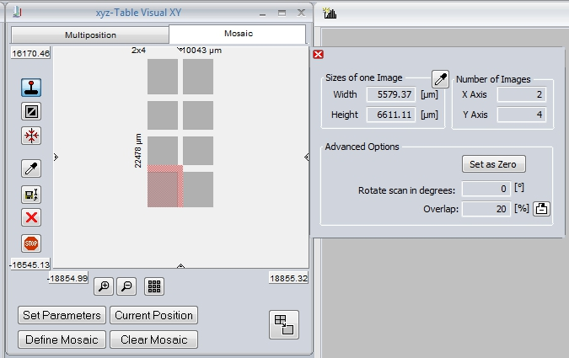

* + In the Tilling dialogue window, click “Set Parameters” to activate the parameter window.
  + Set the number of grey tiles, rows (“X Axis”) and columns (“Y Axis”), to cover the entire ROI. Set the overlap around 20 %.
  + Pink square indicates the current field of view. Grey squares together indicate the whole image area after tiling. Double click any grey square to live view individual tile. Go through all tiles to make sure the grey squares cover the entire ROI.

1. **Dynamic Horizontal Focus**
   * In live view, activate the red crosshair icon in the horizontal focus dialogue window or from the vertical tool bar next to the viewing area. A yellow crosshair shows up in the viewing area.

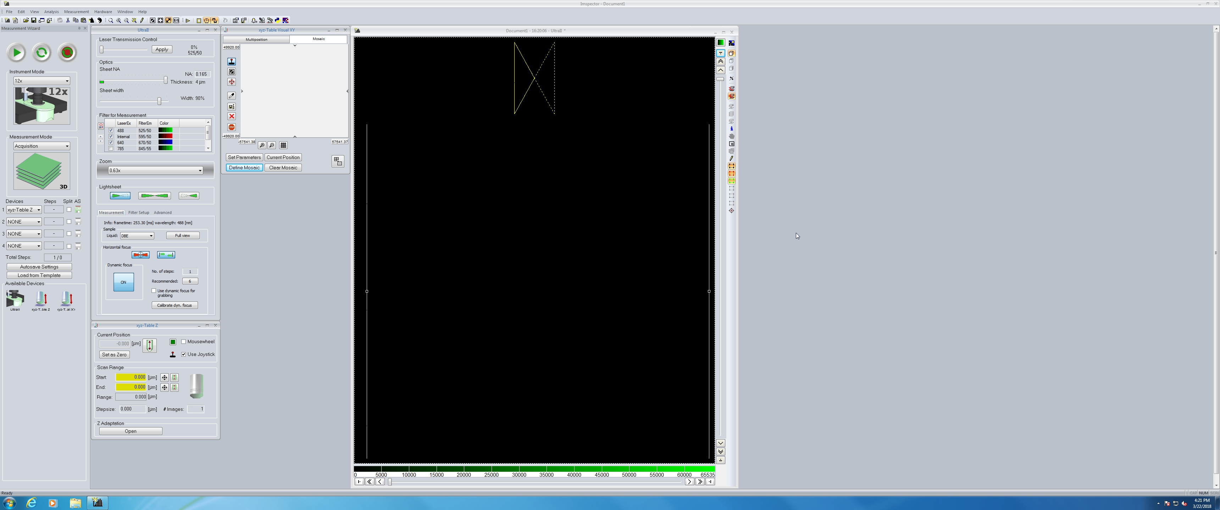 

* + The crosshair size width indicate the width of the horizontal focus under specific magnification. Check horizontal focus across the entire field of view by dragging the crosshair horizontally.
  + Turn on the DHF by clicking “off” to switch to “on” in the DHF dialogue window.
  + In the live view, activate the green dynamic range icon in the DHF dialogue window or from the vertical tool bar next to the viewing area. Two vertical yellow lines show up in the viewing area indicating the range for DHF. If no tiling is needed, drag those lines to cover the ROI in current FOV. Otherwise, widen the range to cover the entire FOV.
  + In the DHF dialogue window, click the “Recommended: 6” to set the “No. of steps” to “6”. (the total DHF steps No. varies based on the user defined DHF range)
  + In the “Advanced” tab of DHF dialogue window, scroll down to set DHF processing algorithm to “Blend”.

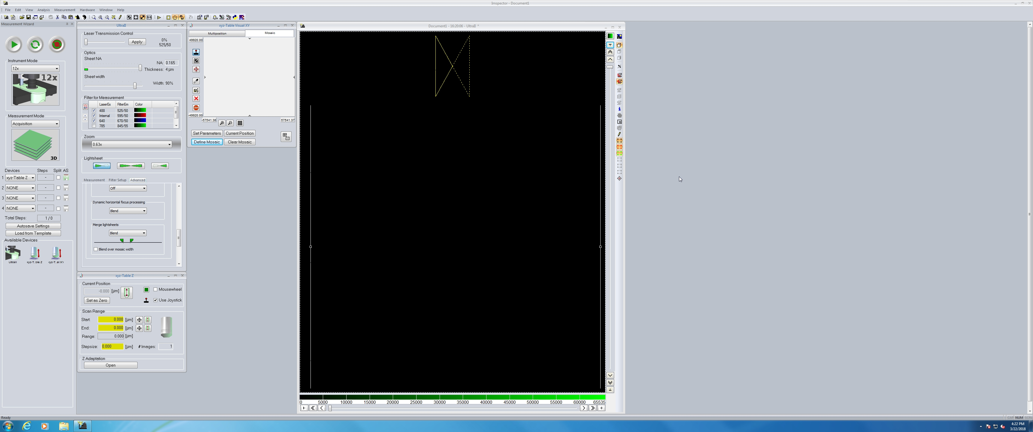

1. **Acquisition and Autosave option.** 
   * Select “Multicolor 3D” from Measurement Mode drop down.
   * Under “Devices”, select 1) xyz-Table Z, 2) Ultrafilter, 3) xyz-Table X, and 4) xyz-Table Y.
   * Click autosave button (click the first icon under AS). Uncheck “Split” for Device 1 “xyz-Table Z”, only check “Split” for Device 2 “Ultrafilter”. 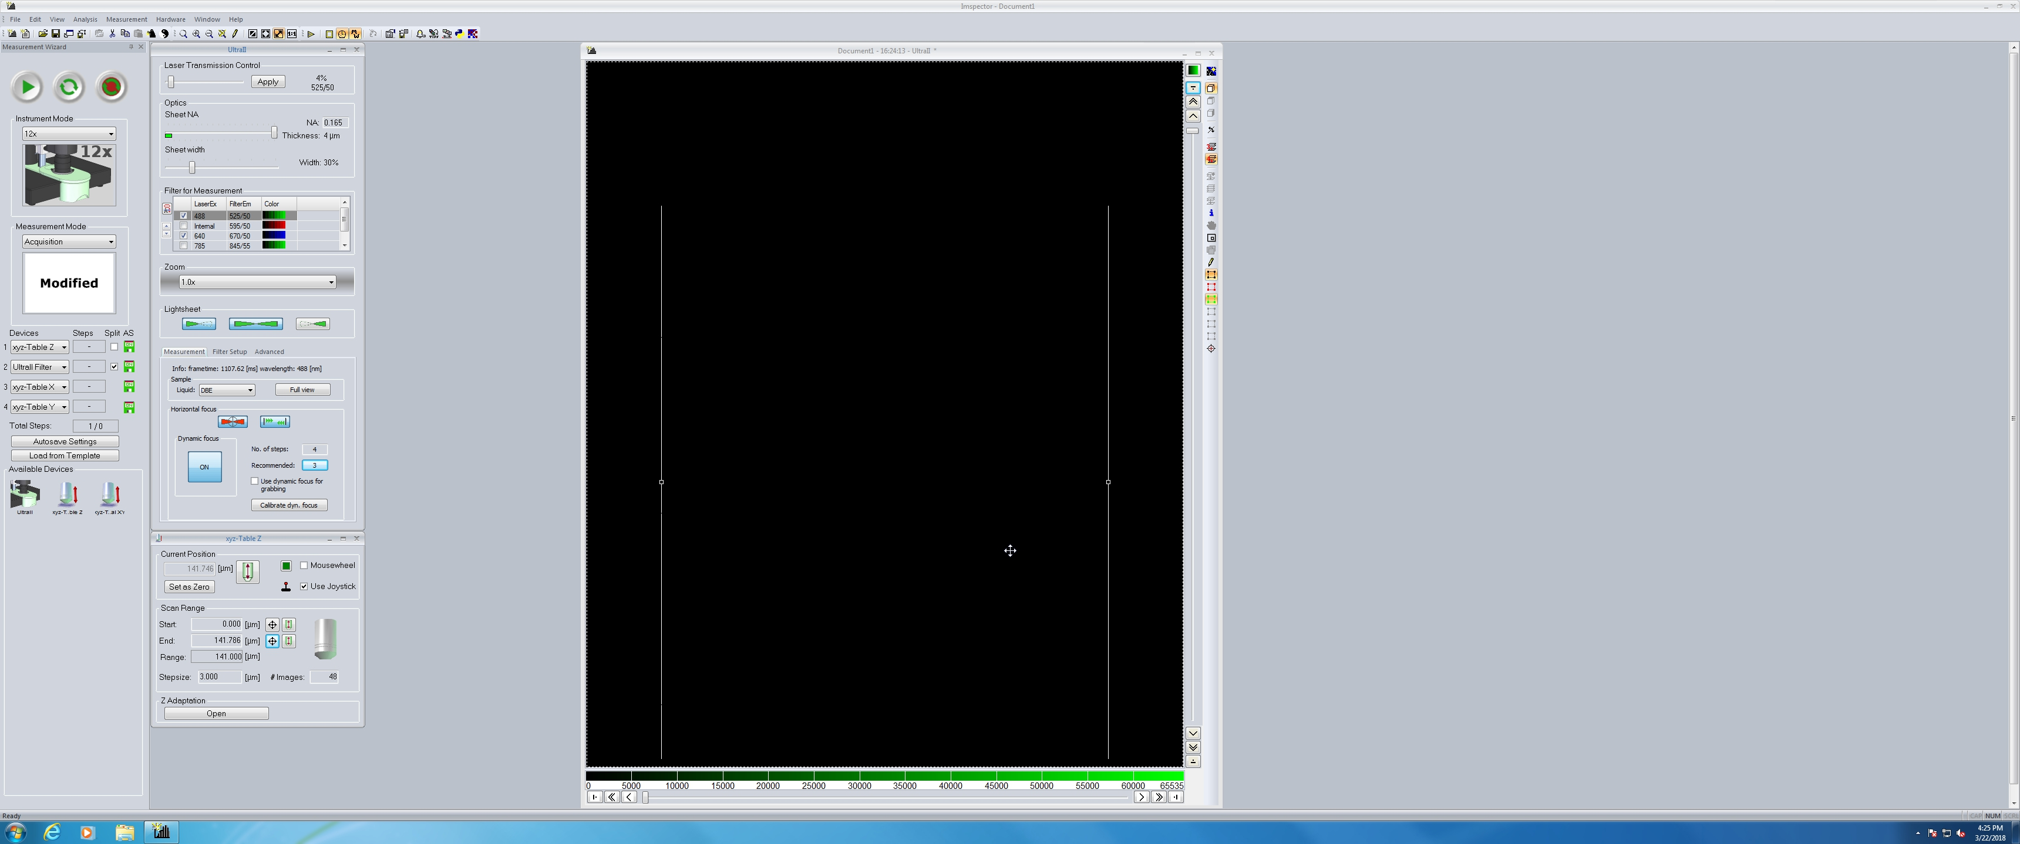
   * Click “Autosave Settings”.
   * In dialogue window, enter folder path to save data to D: drive. Enter file name and “_” at the end. Keep other options as shown. (keep file name short)
   * Click “Advanced settings”.
   * In dialogue window, check “Add meta data only to first image of series”, uncheck “Use fast autosave with streaming”.
   * Click “OK”, then click “OK”.
   * Click Play icon to initiate multicolor 3D imaging. ImspectorPro should update the Total Steps shortly after.

**4**